Introduction

This guide is for Ubuntu 16.04 LTS (Xenial). For the other versions of Ubuntu, instructions might differ.

Desktop Environment Switch

If you don’t like Unity, this is where you should look at. In this guide, I will use Xubuntu as an example, Xubuntu utilizes XFCE desktop environment, which is modern and fast.

<https://itsfoss.com/install-xfce-desktop-xubuntu/>

Samba Shared Folder

Perquisites:

* Port 445 should be open on the server to allow traffic through

To share folders between Linux server and other PCs, follow this guide:

<https://tutorials.ubuntu.com/tutorial/install-and-configure-samba#0>

Remote to Server Using Git Bash

Using Git bash in windows, one can remote control Ubuntu server and even send files to the server.

Perquisites:

* Install SSH server by the following commands
  + ***sudo apt update***
  + ***sudo apt install -y openssh-server***
* Install Git bash if not installed (<https://git-scm.com/downloads>)
* Port 22 should be open on the server to allow traffic through

To access the server:

**Send file**

* Command: scp file_name user_name@server_ip:directory
* Example: scp YourDB.bak user1@192.0.2.9:./

**Remote terminal control**

* Command: ssh user_name@server_ip
* Example: ssh user1@192.0.2.9

SQL Server

Installation

To install SQL server on Ubuntu server, follow this guide:

<https://docs.microsoft.com/en-us/sql/linux/quickstart-install-connect-ubuntu?view=sql-server-2017>

After installation, one user, SA, should be created. You might want to create another user whom has lower access rights. Follow this guide:

<https://docs.microsoft.com/en-us/sql/relational-databases/security/authentication-access/create-a-login?view=sql-server-2017>

Modify Default Data Folders

To enhance control, one might want to change the default location for Data, Log, and Backup folders.

<https://docs.microsoft.com/en-us/sql/linux/sql-server-linux-configure-mssql-conf?view=sql-server-2017>

The folder in this guide can be replaced with any folder you like.

Trouble shooting:

To check if DB logical name is the same as .bak file name - <https://www.mssqltips.com/sqlservertutorial/109/sql-server-restore-filelistonly/>

Database Migration

To migrate DB from one PC to the server, follow this guide:

<https://docs.microsoft.com/en-us/sql/linux/sql-server-linux-migrate-restore-database?view=sql-server-2017>

Connection

Perquisites:

* By default, Port 1433 should be open on the server to allow traffic through. However, suggesting modify the default port before continue.

To change default port number, follow this guide:

<https://docs.microsoft.com/en-us/sql/linux/sql-server-linux-configure-mssql-conf?view=sql-server-2017>

After the guide, one would need to open the new port on the server.

From SQL Server Management Studio

Perquisites:

* Install SQL server express and management studio on your PC (Easier to manage SQL server databases on Windows)
* Install SQL ODBC drivers
  + Windows – <https://www.microsoft.com/en-us/download/details.aspx?id=56567>
  + Ubuntu – <https://docs.microsoft.com/en-us/sql/connect/odbc/linux-mac/installing-the-microsoft-odbc-driver-for-sql-server?view=sql-server-2017>

To access SQL server from internal network:

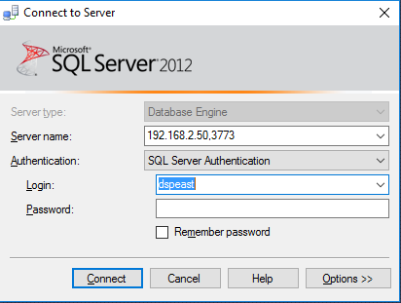

To access SQL server from external network:

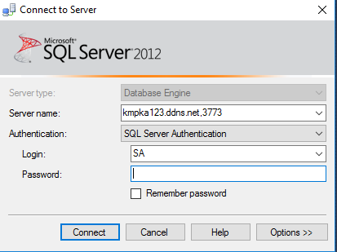

From R Script

Use the following code internally (externally):

*##*

*# Connection*

*##*

*library(odbc)*

*library(DBI)*

*conn <- DBI::dbConnect(odbc::odbc(),*

*Driver = "ODBC Driver 17 for SQL Server",*

*Server = "192.168.2.50 (kmpka123.ddns.net),3773",*

*Database = "HomeLoanDefaultRisk",*

*UID = "dspeast",*

*PWD = "yuheng")*

*##*

*# Read a table from db*

*##*

*DBI::dbReadTable(conn, tbl_name)*

*##*

*# Write a table to db*

*##*

*DBI::dbWriteTable(conn, name = tbl_name, value = data, append = FALSE, overwrite = TRUE, row.names = FALSE)*

*##*

*# List all tables and queries*

*##*

*dfs_tn <- DBI::dbListTables(conn, schema = "dbo")*

# Remote Access

Prerequisites:

* Open port 3389 for xrdp to work

To enable remote access to Ubuntu via XFCE4 environment, follow this guide:

<https://www.tweaking4all.com/software/linux-software/use-xrdp-remote-access-ubuntu-14-04/>

By default, every time you connect to ubuntu, it starts a new session, which is annoying. To change that, in bash, enter:

sudo gedit /etc/xrdp/xrdp.ini

Look for this section:

[xrdp1]

name=sesman-vnc

lib=libvnc.so

username=ask

password=ask

ip=127.0.0.1

port=-1

port = -1 means the remote session is looking for a random free port, change it to 5910 will allow the same session being connected every time.